Policy Brief: Open Government Malaysia

Executive Summary
Open government is about much more than transparency and citizen participation. Collaboration between government and citizens is a key driver of development. Creating an open government, is a joint programme of the whole public sector. It includes ministries and agencies on the national level and municipalities on the local level. The goal is to make the government more responsive to citizens with the ultimate goal of improving the quality of governance and quality of services that citizens receive. This is only possible if the structures of the government and its functions, services and reforms are understandable to citizens and if participation in policy-making and service planning is feasible. Enhancing open government needs to be part of daily work and development of the public administration.
Additionally the COVID-19 pandemic has compelled governments and citizens to take unprecedented, mitigating measures. Again trust and participation is key for successful response and recovery. It puts on a glaring spotlight on the ability of the government to provide transparent communications and provision of digital services.
To ensure better and functional government reforms, the government is urged to commit to the principles of transparency and openness by endorsing the Open Government Partnership (OGP) declaration. In order to uphold the principles of OGP, the government should promote accountability by enabling journalists, researchers, government officials, and the public to scrutinize, question, and ultimately improve how government works.
The key elements include:
- Enhance citizens’ possibilities to participate in the preparatory work of public administration, decision-making and development projects;
- Contribute to open data and meaningful access, by providing valuable data and information to the society, through user-friendly information format including infographic visualisation;
- Openness in the public sector, public servants and/or government officials need support and training to develop interaction and new information management skills to foster a better participation of the public.

This document includes the definition of Open Government Partnership, the importance of open government policy, and the existing initiatives in Malaysia that should be given priority. Malaysia is currently well poised to join OGP, led existing initiatives by The Malaysian Administrative Modernisation and Management Planning Unit (MAMPU), and only needs a Freedom of Information Act (FoIA) for which the Legal Affairs Division (Bahagian Hal Ehwal Undang-undang-BHEUU) has already begun the process of drafting legislation. This document also covers examples of the successful implementation of open government in other countries.

Introduction

What is Open Government Partnership
The Open Government Partnership (OGP) is a voluntary global initiative aimed at building trust and fostering collaboration between governments and their citizens to improve the development outcomes. Specifically, this initiative seeks to secure concrete commitments from governments to promote transparency, empower citizens, fight corruption, and harness new technologies to strengthen governance.
Since 2011, the OGP has gained rapid traction with 79 governments presently having joined the initiative and endorsed the Open Government Declaration. Collectively, over 4,000 commitments have been made globally.

How to become a member
Becoming a member of the OGP is a straightforward process. In order to join, the member country must first satisfy the eligibility criteria. This means that a minimum level of commitment to open government principles, in four key areas, have to be met:
- Budget transparency,
- Access to information,
- Income and asset disclosures, and
- Citizen engagement
Once the eligibility has been confirmed, the interested government needs to identify a lead ministry or agency that will start formulating the Open Government National Action Plan (NAP) in close consultation with civil society and citizen groups.

National Action Plan
The NAPs are at the core of a country’s participation in OGP and contain the members’ commitments over a 2-year period. These commitments should focus on national open government priorities, relevant to the values of transparency, accountability and public participation; and be specific, time bound, and measurable.
To strengthen the dialogue between civil society and government in the formulation of the NAP, comprehensive involvement of a wide range of stakeholder groups, through analysis of inputs received from the consultations, is an essential for a successful reform process.
In order to measure the implementation progress of NAPs, benchmarks with timeframe and annual achievements need to be stipulated for each commitment. To ensure that implementation progress is assessed and measured in an unbiased manner, an independent reporting mechanism (IRM) ensures bi-annual reporting in all member countries. (See Appendix A.1)

How OGP contributes to the reforms
The idea is that the NAP generates a cycle of consultations, formulation of open government commitments, implementation of these commitments, and monitoring and evaluation of progress in achieving the commitments. This process is expected to evolve into a cycle that will generate increasingly ambitious reforms, enhance citizen participation, and produce stronger results. The idea is that the more civil society is engaged, the higher the likelihood of NAP policies and programs to be meaningful and to be implemented. The more the citizens see the governments initiating meaningful reforms through OGP, the more they realize that their engagement matters and thus would want to stay involved. Progressively, as governments become increasingly comfortable with open government reforms, they will also become more receptive to civil society input and participation.

Background

Why Open Government in Malaysia
An Open Government Policy can help to provide the evidence and facilitate the exchange of information and data across government agencies, help to inform and improve public policy and program quality, plus empower civil society to contribute more and be involved in better policy-making and program implementation.
It is inline with Malaysian Digital Government Strategy and Public Sector Digitalisation Plan to:
- Capitalize local authorities for quality services
- Enhancing government project management for better and faster outcomes
- Enhancing service delivery with citizens at the centre

Existing initiatives and stakeholders
Malaysia already has several ongoing open government related initiatives:

Digital Government and Citizen Centric Initiatives
The Malaysian Administrative Modernisation and Management Planning Unit (MAMPU) has undertaken a comprehensive long term Digital Government Strategy Plan, which has the following policies which are aligned to open government goals:
- The Malaysian Public Sector ICT Strategic Plan 2016-2020 contains national e-Government strategy for Malaysia;
- Public Sector Digitalization Plan which a more holistic and comprehensive strategy in adopting digital transformation to the public sector;
- The Communications & Multimedia Blueprint 2018-2025 which is a document to empower and strengthen the Malaysian Communications and Multimedia sector as a leader in the region towards a people-centric communications and making full-fledged digital nation to a reality;
- Public Sector Open Data as a catalyst for Government’s citizen-centric initiatives

Open Data
Open data is data that can be used freely, is able to be shared and reused by the people, as well as the Government and public agencies for various purposes. It acts as the catalyst in the Government’s citizen-centric initiative. The implementation of Government open data will improve the transparency of Government services delivery through sharing of data that is accurate, fast and relevant as well as increase the nation’s digital economy productivity through new industries or innovations with the involvement of the people and the business community. It also places Malaysia on par with other countries in the Digital Government initiative.

The meeting of the Steering Committee NKEA CCI Communications Content and Infrastructure (CCI) which was chaired by YB Minister of Communications and Multimedia on 29 May 2014 resolved that the Malaysian Administrative Modernisation and Management Planning Unit (MAMPU) would implement the Development of the Public Sector Open Data Platform. In line with that decision, the Ministers Cabinet Meeting on 20 August 2014 agreed that the public sector agency would carry out the open data initiative so as to realise the Government’s aspiration.

The Public Sector Open Data (DTSA) portal was developed in 2014 to support this aspiration of implementing open data. The DTSA portal enables the government open data to be easily accessed centrally from an official source.

Freedom of Information Enactment Act

The Legal Affairs Division (Bahagian Hal Ehwal Undang-undang – BHEUU) under the Prime Minister’s Department has set up a Steering Committee and a Technical Committee aimed at reviewing the current legislations in relations to the Freedom of Information and subsequently studying the feasibility of drafting a Federal level Freedom of Information Act. The Committees will conduct sufficient stakeholders consultation and engagement to ensure that the views of all parties are heard. The civil society on the other hand initiated a National Campaign for a Freedom of Information Act in 2006 and has since drafted a model Right to Information Bill, which has undergone extensive consultations.

Open Contracting Partnership
Open Contracting Partnership is another Open Data initiative to enhance information transparency related to Government procurement in line with Government aspirations.
Open Contracting Data Standards (OCDS) was first introduced in 2014 to enable data publications according to structured standards. These standards form the main foundation towards more sustainable data sharing and are used by all OCP participating countries.

At the Federal level MAMPU led by YBrs. Dr Suhazimah binti Dzazali, the Deputy Director General of ICT together with the Director of Digital Government Division, YBrs. Dr. Yusminar binti Yunus held a discussion together with the Open Contracting Partnership (OCP) team representative, Ms. Bernadine Fernz on 22 October 2018 at MAMPU Putrajaya to discuss the direction that needs to be formulated to assist Malaysia in adapting to OCP towards becoming an Open Government.

At the sub-national level for Selangor and Penang government the UK Government Digital Services Global Digital Marketplace Programme (GDMP) with Development Gateway is undertaking research that will identify areas where Selangor State Government can collaborate with the Global Digital Marketplace Programme (GDMP) to strengthen procurement policies, systems, assurance processes, capacity, and transparency, drawing on the experience of the UK Government Digital Service and the state’s own perspective. Areas identified will help in the design of activities aiming to increase procurement competitiveness, improve the functioning of domestic markets and supply chains, reduce opportunities for corruption, and improve value for money.

Open Parliament
Parliamentary monitoring organizations (PMOs) are working to create strong, open and accountable parliaments, through enhancing citizen participation in the legislative process and bringing parliaments closer to the people they represent.

In Malaysia, Sinar Project through it’s Open Parliament programme provides access to searchable archives of Parliamentary Questions and Answers along with legislative open data on MPs

Since November 1998 has also started uploading and made accessible all materials including written replies and submitted reports online on the same day on the Parliament website. Prior to this, Parliament has also started livestreaming proceedings to make it more accessible to all.

Malaysia's Current Eligibility Status
The existing initiatives and efforts led by MAMPU in the government, show Malaysia is very much eligible for joining OGP according to the criteria listed above in this document. In order to be more aligned with the OGP requirements and criteria, the government should initiate Freedom of Information (FoI) from the federal level to local authorities, where the Legal Affairs Division has already begun the process at the federal level. The government should also add more meaningful data and information on disaster and epidemic resources, for instance a portal for responses and recovery from the economic aspect.

Open Government Approach and Results

Case studies

Malaysia

Example 1: Planning and Delivery of School Infrastructure

The prototype by MAMPU project sought to improve the planning and delivery of public health and education infrastructure by developing a data-driven tool for identifying optimal locations for schools and hospitals. Consolidating data from government project monitoring system (SPP II) into Open Contracting for Data Infrastructure Format (OC4IDS) and

Inspired by the huge investment needed for education and health facilities in Malaysia. In 2018, the government allocated more than RM650 million (US$155 million) to build preschools, primary schools, matriculation centres and other educational facilities. Similarly, the government spent around RM1.4 billion (US$334 million) on building hospitals and other healthcare centres that same year.

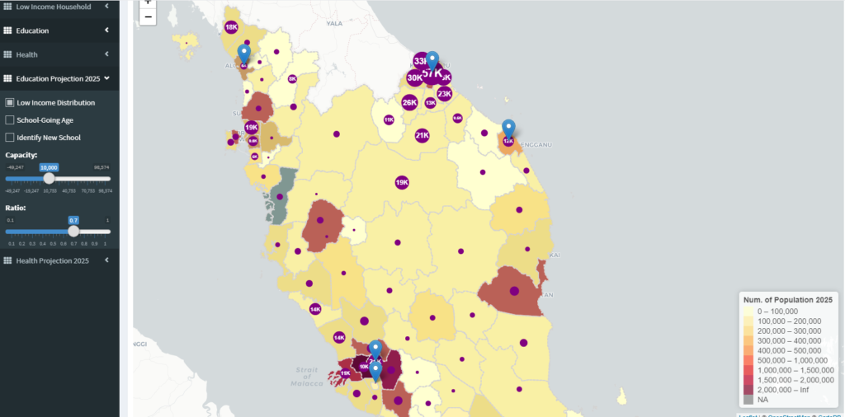

Indonesia
The government established Open Government Indonesia (OGI) as a platform for communication between interested parties. Initially, OGI had a core team consisting of five government agencies, namely, the President’s Delivery Unit for Development Monitoring and Oversight (UKP-PPP), Ministry of Foreign Affairs, Ministry of Communication and Information, National Planning Agency, and Central Information Commission and later appointed four civil society organizations (CSO) to join the OGI Core Team.
In 2013, the Indonesia government decided to add another two government agencies to the core team, the Ministry of Administrative Reform and Ministry of Home Affairs. As a result of this extension, civil society core team members requested a further extension of the team, in order to provide equal representation for government and civil society. An open recruitment process was conducted and three organizations with different backgrounds were chosen, based on criteria set during discussions between the government and the CSO Core Team. (See Example 2)
Example 2: LAPOR! - A Crowdsourcing Project for Public Services Improvement in Indonesia
LAPOR! is an online complaints management system that allows citizens to report on public services. With various digital technologies such as e-mail, text messaging, online reporting, etc., citizens can report anything from teacher absenteeism, damaged roads, and improper behavior by public servants. Once the report is filed, and following validation by the UKP-PPP team, it is forwarded to the relevant ministry or government agency. The concerned institution then sends a response through LAPOR! with an SMS notification to the complainant about action taken. This whole process is designed to take no more than 10 days.
If a public institution fails to respond to a complaint within one month, the LAPOR! team reports this to the President’s office, creating a strong disincentive for non-compliance. A major strength of LAPOR! is that it provides a speedy, low-cost channel for citizens to voice their concerns and influence public services through modern technology. Moreover, once participating citizens notice that their problems have been addressed they are likely to stay engaged and continue reporting.

The Philippines
The Philippine Government sees open government as a way to operationalize and institutionalize People Power. It will take on the grand challenges of improving public services, increasing public integrity and more effectively managing public resources: all in line with the Aquino administration’s pursuit of kung walang corruption, walang mahirap. In crafting this Action Plan for the OGP, the Philippines Government consulted with national networks of civil society organizations (CSOs).
The “Open Data Portal” in the Philippines, consolidates and makes government datasets publicly available. This initiative provides opportunities for citizens to access public information in areas such as public services provision and financial management. (See Example 2)
Example 3: The Open Data Philippines Initiative
Following the membership in the OGP took significant steps towards realizing the potential of open data. A key achievement was the launch of the Open Data Portal (data.gov.ph) in 2014. The portal is a single access point with the objective to make government data accessible and useful to the public by consolidating datasets of different government agencies.
Various applications and infographics make the portal user-friendly and facilitate the access and interpretation of the data. The portal also encourages the public to comment on the data available, the utility of the data, as well as provide suggestions on how to improve it. One specific accomplishment includes hosting interactive dashboards that helps users establish meaningful relationships between raw data and process information. Another is the searchable line-item database or procurement transactions.

Conclusion and Recommendations
Open government initiatives should not exist in isolation. It is indeed a critical policy area for the achievement of a number of different policy outcomes in diverse domains. Open government reforms should thus be citizen-centric to ensure the widest possible impact and its multidimensional and transversal nature needs to be acknowledged. This policy brief suggests the OGP initiative to be an important drive in advancing the principles of good governance and open government.
This brief ends by proposing suggestions for improving good governance and open government:
- Institutionalizing the OGP initiatives
The execution of current initiatives are currently limited to certain parties at different levels of national and state governments. A good governance initiative including open government needs broader representation in the legislature, the judiciary, and among non-elected officials along with specific coordinated national commitments.
- Strengthen the CSO component and capacity of public servants
The ability to adequately provide inputs and oversee progress are at the core of the OGP. There is a need for capacity development and support to assist CSOs, citizen groups and public servants in effectively monitoring, evaluating, validating data, and providing inputs and implementation of the National Action Plans. It will also support improved citizen participation and people centric government service delivery.
- Consolidate and promote achievements
An independent review of initiatives could be useful to help demonstrate the benefits. Promoting the existing initiatives would encourage more participation and adoption from all stakeholders.

- Involvement of media
Newspapers, television, the Internet and social media are important outlets through which journalists play a watchdog role in holding leaders to account in relation to their constituencies. Enabling this function with appropriate policies and laws is an essential task of any government interested in promoting the values of good and democratic governance. Increased transparency will also build trust and support for open government inititives.

Appendix

Appendix A: Government Point of Contact Manual Version 3; March 2017

Participation and Co-creation When Implementing, Monitoring, and Reporting A National Action Plan; pg 24.

Guidance On Drafting OGP Documents: National Action Plan and Self-assessment Report; pg 28.

Guidance on Drafting Ogp Documents: National Action Plan and Self-assessment Report; pg 29-30.

Appendix B: Commitment Template
- Example
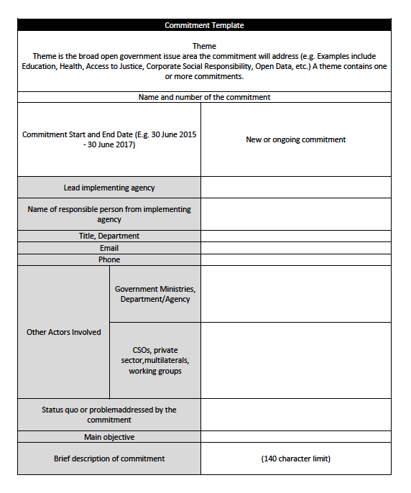
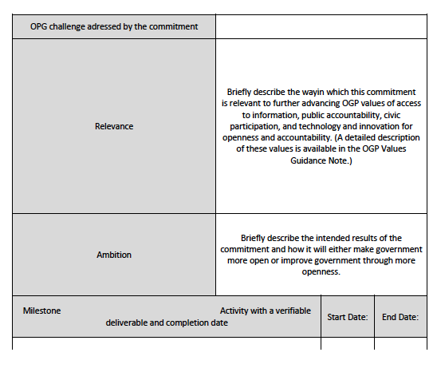

Open Government Partnership. “What is the Open Government Partnership?”. http://www.opengovpartnership.org/about
Open Government Declaration. https://www.opengovpartnership.org/process/joining-ogp/open-government-declaration/
Becoming a member of Open Government Partnership. https://www.opengovpartnership.org/process/joining-ogp/
Open Government Partnership: Four Year Strategy 2015-2018. p. 13-14
“Lapor! Layanan Aspirasi dan Pengaduan online rakyat.” http://www.lapor.go.id
M. F. Capili. 2015. Open Government Philippines and Open Data Philippines: Review Documentation and Recommendations.
https://www.malaysia.gov.my/portal/content/30024

